**SOFTWARE**

**REQUIREMENTS**

**SPECIFICATIONS**

For

**Inventory Management System**

**Prepared By :-**

***M.Samraat***

***S.kabinesh***

***R.Kathirvel***

**1.Introduction :**

**1.1 Purpose**

The main objective of this document is to illustrate the requirements of the project Inventory Management system. The document gives the detailed description of the both functional and non-functional requirements proposed by the client.The purpose of this project is to provide. The purpose of an inventory management system is to efficiently and effectively oversee the entire lifecycle of a company's goods, from procurement to production and, ultimately, to customer delivery. This project describes the hardware and software interface requirements using ER diagrams and User case diagrams.

**1.2 Scope**

This document covers the requirements for the Inventory Management System. This software will provide a graphical environment in which the users of the system will be able to perform various operations that are associated with storing, marinating, updating and retrieving Product information. The purpose of this is to guide developers in selecting a design that will be able to accommodate the full-scale application. This system will capture information about customer’s personal details products and their quantities. Storing updating and retrieving in a fast and accurate way.

**1.3 Definitions, Acronyms, and Abbreviations**

The Inventory Management System has to handle records for number of products and maintenance was difficult. Though it has used an information system, it was totally manual. Hence there is a need to upgrade the system with a computer-based information system.

Software Requirements Specification

Page 2

1.4 References

An Integrated Approach to Software Engineering Approach - Pankaj Jalote

Software Engineering A Practitioner’s Approach - Roger S Pressman

1.5 Overview

The purpose this document is to present a detailed description of the Inventory

Management System. It will explain the purpose and features of the software, the interface of

the software, what the software will do, the constraints under which it must operates and how

the software will react to external stimuli. This document is intended for both the end users

and the developers of the software.

**1.4 Reference**

An Integrated Approach to Software Engineering Approach - Pankaj Jalote Software Engineering A Practitioner’s Approach - Roger S Pressman

**1.5 Overview**

The purpose this document is to present a detailed description of the Inventory Management System. It will explain the purpose and features of the software, the interface of the software, what the software will do, the constraints under which it must operates and how the software will react to external stimuli. This document is intended for both the end users and the developers of the software.

**1.6 Document Conventions**

* Convention for main title

Font face:Cambria

Font style:Bold

Font size:18

* Convention for subtitle

Font face:Cambria

Font style:Bold

Font size:14

* Convention for body

Font face:Cambria

Font size:12

**2.Overall Descriptions:**

2.1Product perspective

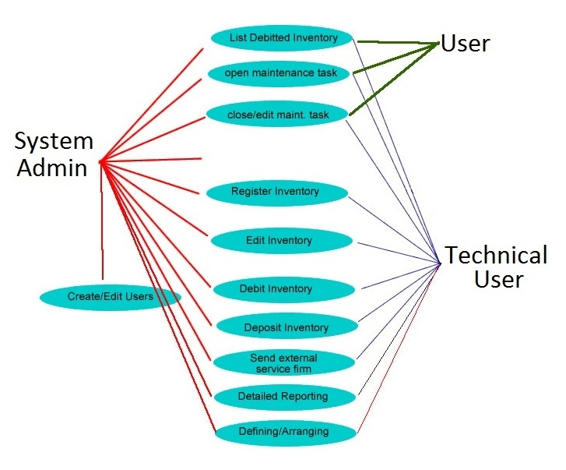

* Use case for Inventory Management System
* ER diagram for Inventory Mnagement System(Product Function)

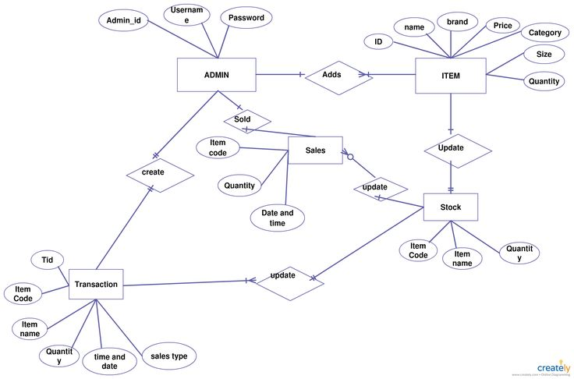

**3.External Interface Requirements**

**User Interfaces :** GUI along with meaningful Frames and buttons , Reports are generated as per the requirement .

**Hardware Interfaces:** Hardware Environment Dual Core 2nd generation/ System Configuration RAM-4 GB HDD-80GB Operating system Windows 7/8/8.1/10

**Software Interfaces :**Front End Java, Back End MySQL

When invalid inputs are given to the modules then the error messages will be popped up in order to inform the user that the input provided is not taken by the database. When incomplete information is provided by the user and the user tries to submit the form in order to store the details in the database the system will pop up a message box asking the user to enter all the details required.

**4. System Features**

A product feature is a specific function or characteristic of a product that provides value to customers. It can include capabilities, design elements, or performance upgrades. For product managers, defining and prioritizing features to build is a key aspect of the role.

**5.1 Performance Requirement**

A good inventory management program is critical to being able to effectively manage an MRO storeroom. Best practices indicate that overall inventory accuracy should be 95% of total cycle counts. This requires that all tools and parts are ready to be used as soon as they are needed.

* To measure performance in inventory management, one of the most common metrics to use is the “number of inventory turns.”
* This number is calculated using the ratio of the value of purchased stock to the value of stock on hand.
* The metric, number of inventory turns, aims to measure the movement of stock.

**5.2 safety requirement**

Safety stock and reorder point are essential components of effective inventory control. By maintaining adequate safety stock and using a reorder point system, businesses can protect themselves from stockouts, improve customer satisfaction, and reduce inventory costs.

**5.3 Security Requirement**

System will use secured database

- Normal users can just read information but they cannot edit or modify anything except

their personal and some other information.

-System will have different types of users and every user has access constraints

- Proper user authentication should be provided

- No one should be able to hack users’ password

- There should be separate accounts for admin and members such that no member can

access the database and only admin has the rights to update the database.

**5.4 Requirement attributes**

There may be multiple admins creating the project, all of them will have the right to

create changes to the system. But the members or other users cannot do changes

-The project should be open source

- The Quality of the database is maintained in such a way so that it can be very user

friendly to all the users of the database

- The user be able to easily download and install the system

**5.5 Business Rules**

A business rule is anything that captures and implements business policies and practices. A rule can enforce business policy, make a decision, or infer new data from existing data.This includes the rules and regulations that the System users should abide by. This includes the cost of the project and the discount offers provided. The users should avoid illegal rules and protocols.

Neither admin nor member should cross the rules and regulations.

**5.6 User Requirement**

-Product Categorization.

-Product Measurement.

-Product History.

-Stock Inquiries.

-Cycle Counting.

-Collaborative Inventory.

-Automatic Stock-out Reports.

-Vendor Managed Inventory.

**6. Other Requirements**

**6.1 Data and Category Requirement**

For an effective inventory management system, essential data and category requirements include product information such as unique identifiers, names, and categories, along with details like cost and selling prices. Inventory levels, including current stock quantities and reorder parameters, are crucial for maintaining optimal stock levels. Supplier information, purchase orders, and lead times are essential for managing the procurement process. Sales orders and transaction histories facilitate tracking product movement and revenue generation. Location information ensures efficient warehousing, while user roles and security features control system access. Reporting and analytics tools enable data-driven decision-making, and integration with other systems streamlines processes. Alerts for low stock and order statuses, coupled with robust data security measures, contribute to a well-rounded system. An audit trail ensures accountability, while scalability and customization options accommodate business growth and specific needs.

**6.2 Appendix**

A: Admin, Abbreviation, Acronym; B: Books, Business rules; C: Class, Client,Conventions; D: Data requirement, Dependencies; G: GUI; K: Key; ; M:Member; N: Non-functional Requirement; O: Operating environment; P:Performance,Perspective,Purpose; R: Requirement, Requirement attributes; S: Safety,Security, System features; U: User, User class and characteristics, User requirement;

**6.3 Glossary**

1. *Inventory Management System (IMS):*

- Definition: A software application or system that helps businesses track, manage, and control their inventory.

2. *Product ID:*

- Definition: A unique identifier assigned to each product in the inventory.

3. *Stock Keeping Unit (SKU):*

- Definition: A distinct identification code often assigned to individual items for inventory tracking.

4. *Reorder Level:*

- Definition: The minimum quantity of a product that, when reached, triggers the need to reorder to avoid stockouts.

5. *Reorder Quantity:*

- Definition: The quantity of a product to be ordered when the inventory reaches the reorder level.

6. *Lead Time:*

- Definition: The time it takes for a supplier to deliver an ordered product after a purchase order is placed.

7. *Purchase Order (PO):*

- Definition: A document issued by a buyer to a supplier, specifying products, quantities, and prices for purchase.

8. *Sales Order:*

- Definition: A document generated by the seller confirming the sale of products to a customer.

**6.4 Class Diagram**

The class diagram for an inventory management system encapsulates the key entities and their relationships within the system. The central class, "Inventory," manages the overall inventory, including attributes such as inventory ID, location, and total quantity. The "Product" class represents individual items, encompassing details like product ID, name, and pricing. The "Supplier" class handles information about product suppliers, with attributes like supplier ID and contact information. The "PurchaseOrder" and "SalesOrder" classes track transactions, including order details and associated costs or revenues. These classes interact to facilitate essential functions such as adding or removing products, updating prices, and managing purchase and sales orders. This class diagram provides a concise visual representation of the core elements and their relationships within the inventory management system

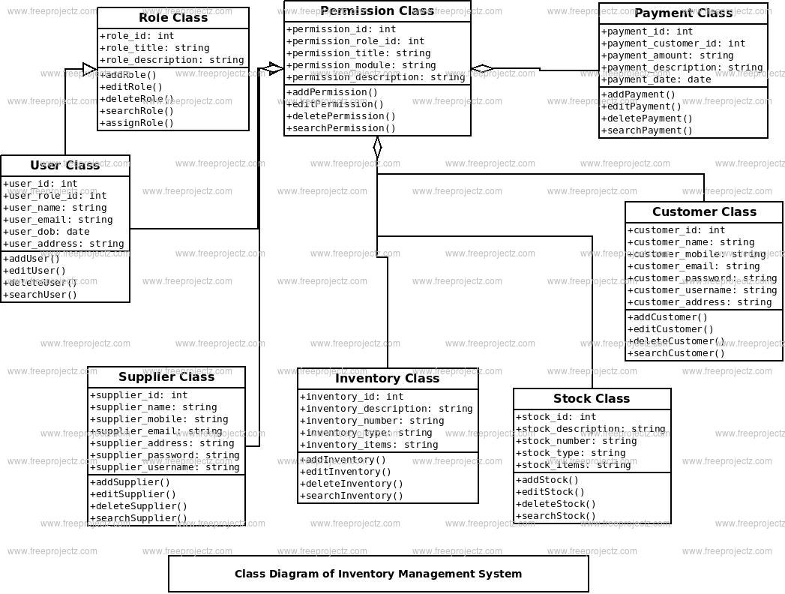

Software Requirements Specification

Page 2

1.4 References

An Integrated Approach to Software Engineering Approach - Pankaj Jalote

Software Engineering A Practitioner’s Approach - Roger S Pressman

1.5 Overview

The purpose this document is to present a detailed description of the Inventory

Management System. It will explain the purpose and features of the software, the interface of

the software, what the software will do, the constraints under which it must operates and how

the software will react to external stimuli. This document is intended for both the end users

and the developers of the software.

Software Requirements Specification

Page 2

1.4 References

An Integrated Approach to Software Engineering Approach - Pankaj Jalote

Software Engineering A Practitioner’s Approach - Roger S Pressman

1.5 Overview

The purpose this document is to present a detailed description of the Inventory

Management System. It will explain the purpose and features of the software, the interface of

the software, what the software will do, the constraints under which it must operates and how

the software will react to external stimuli. This document is intended for both the end users

and the developers of the software.

Software Requirements Specification

Page 2

1.4 References

An Integrated Approach to Software Engineering Approach - Pankaj Jalote

Software Engineering A Practitioner’s Approach - Roger S Pressman

1.5 Overview

The purpose this document is to present a detailed description of the Inventory

Management System. It will explain the purpose and features of the software, the interface of

the software, what the software will do, the constraints under which it must operates and how

the software will react to external stimuli. This document is intended for both the end users

and the developers of the software.

Software Requirements Specification

Page 2

1.4 References

An Integrated Approach to Software Engineering Approach - Pankaj Jalote

Software Engineering A Practitioner’s Approach - Roger S Pressman

1.5 Overview

The purpose this document is to present a detailed description of the Inventory

Management System. It will explain the purpose and features of the software, the interface of

the software, what the software will do, the constraints under which it must operates and how

the software will react to external stimuli. This document is intended for both the end users

and the developers of the software.